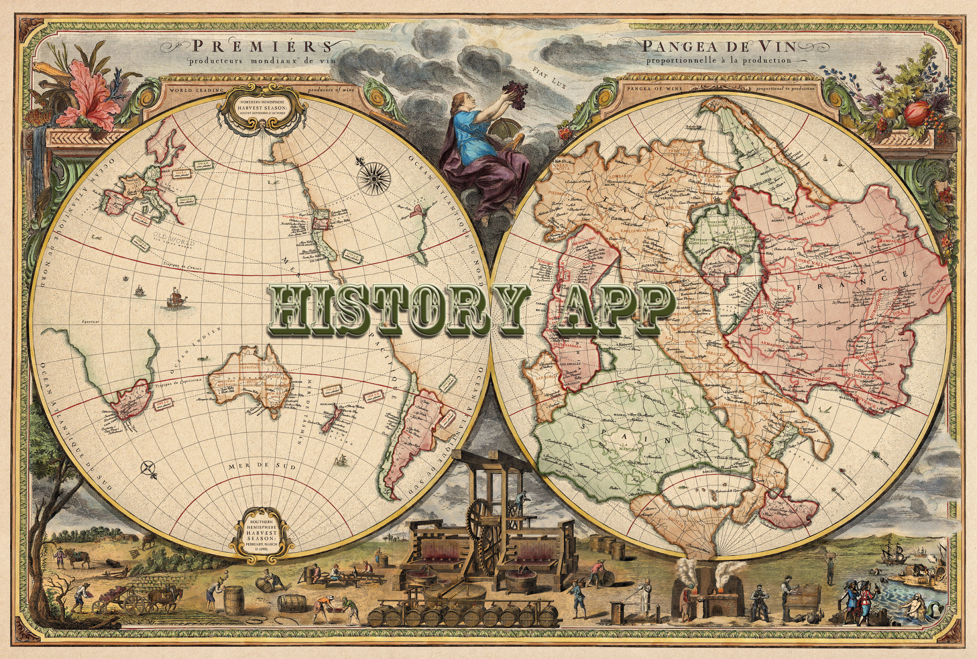

DESIGN dOCUMENT
Florida International University
Senior Project
CIS 4911
10/1/2014

Mentor:
Tracy Beeson

Development Team:
Ariel Diaz
Yesenia Yser

Copyright and Trademark Notices

I have carefully assessed the Software Design Document for the History App. This document has been completed in accordance with the requirements of the FIU System Development Methodology.

All materials available on this document are protected by copyright laws and international copyright treaty provisions. This material has been placed on this Internet site under the authority of the copyright owner for the sole purpose of viewing of the materials by users of this site. Users are not authorized to download or transmit any of these materials electronically, or to otherwise reproduce any of the materials in any form or by any means, electronic or mechanical, including data storage and retrieval systems, recording, printing or photocopying.
© 2014 FLORIDA INTERNATIONAL UNIVERSITY. ALL RIGHTS RESERVED

We fully accept the changes as needed improvements and authorize initiation of work to proceed. Based on our authority and judgment, the continued operation of this system is authorized.

_______________________________ _____________________
NAME DATE
Project Leader

_______________________________ _____________________
NAME DATE
Operations Division Director

_______________________________ _____________________
NAME DATE
Program Sponsor Representative

_______________________________ _____________________
NAME DATE
Program Area/Sponsor Director

Abstract

This document contains the software requirements for the History Explorer system. This project is one out of 18 Senior Projects for Fall 2014 at Florida International University.

These software requirements were established according to requests from the mentor, Tracy Beeson, and her passion for History. The system to be developed is for tourist and adventurers to route a historical virtual tour at a certain GPS coordinate, address, or city. This document follows the IEEE standard for a requirements specification document, with some variations.
Software Requirement Document

TABLE OF CONTENTS

Page #

1.0 Chapter 1: Introduction 1-1
1.1 Problem Definition 1-1
1.2 Design Methodology 1-1
1.3 Definitions, Acronyms and Abbreviations 1-2
1.4 Overview of Document 1-2
2.0 Chapter 2: System Design 2-1
2.1 Overview 2-1
2.2 Subsystem Decomposition 2-1
2.3 Hardware and Software Mapping 2-1
2.4 Persistent Data Management 2-1
2.5 Security/Privacy 2-1
3.0 Detailed Design 3-2
3.1 Overview 3-2
3.2 Static model 3-2
3.3 Dynamic model 3-2
3.4 Code Specification 3-2
4.0 Glossary 4-3
5.0 Appendix 5-4
5.1 Appendix A 5-4
5.2 Appendix B 5-4
5.3 Appendix C 5-4
5.4 Appendix D 5-4
6.0 References 6-5

Chapter 1: Introduction
History Explorer connects you with the past. It provides accounts of historical places and events while making it accessible at the palm of your hand. This application gets its content from the vast knowledge of many historians and their years of experience in the field. You will be able to see a map showing all of the historical places of interest around you and History Explorer will show you the exact address of the place, hours of operation, and phone number.

1.1 Problem Definition

Many systems in today’s application market provide users with an array of features for travel, such as recommended sightseeing locations, user reviews on hotels and restaurants. However there is a gap in the market for documentation on historical events and places. History Explorer solves this problem by giving users a connection to history in a modern and accessible way. It grants access to audio, image and document files that explain historical events in detail.

1.2 Design Methodology
Due to results obtained periodically, The Unified Software Development was used for the project’s lifecycle to be able to develop History Explorer. With this model, the progress of the project can be measured during each iteration of the processes. This allows for less costly mistakes since incremental changes happen through each step. (Figure 1.2.1 Unified Software Development Process)
Based off the use cases’ work flow, functional and non-functional requirements, from the Requirement Document (RD), a sequence diagram, minimal class diagram, a detailed class diagram, and a deployment diagram was created. The sequence diagram was created for each use case being implemented into the project, using the system requirements which help understand of how work flow operates and interact with other systems. A minimal class diagram, deployment diagram, and detailed diagram use the sequence diagrams information to be created.
The detailed class diagram is created to understand the interactions and behavior among all classes, while the minimal class diagrams focus on the association between all classes and packages they are in. The detailed class diagram also describes each class, providing an insight to important attributes and methods within the class. The deployment diagram demonstrates hardware and software components and how each piece connects.
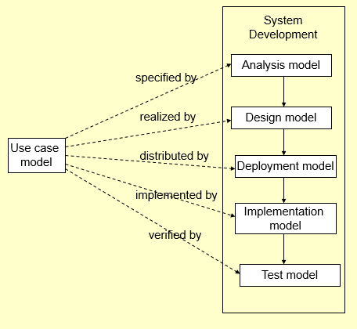
Figure 1.2.1 Unified Software Development Process

1.3 Definitions, Acronyms and Abbreviations
For more definitions, please see the Glossary.
Android - Android is a mobile operating system (OS) based on the Linux kernel and currently developed by Google.
Web Application - is any application software that runs in a web browser and is created in a browser-supported programming language (such as the combination of JavaScript, HTML and CSS) and relies on a web browser to render the application.
Database - a comprehensive collection of related data organized for convenient access, generally in a computer.
Admin - Application content administrator.
History Map Screen - Map showing nearby historical places.
Historical Place of Interest - Place with a Map Marker on the History Map Screen.
Historical Tour - Route from place A to place B which displays Historical Places of Interest along the path.
Peer-reviewed documents - Documents that have been reviewed by history scholars.
Drafted Item - a preliminary version of a piece of writing, audio or image that is sent over to the Admin to be published.
Published Item - a finished version of a piece of writing, audio or image that was approved by the Admin and is accessible by the users.
Map Marker - A visual element that is used to mark a map point within a map.
Geolocation - the process or technique of identifying the geographical location of a person or device by means of digital information processed via the Internet.
Global Positioning System (GPS) - is a space-based satellite navigation system that provides location and time information in all weather conditions, anywhere on or near the Earth where there is an unobstructed line of sight to four or more GPS satellites.
Responsive Design - a web design approach aimed at crafting sites to provide an optimal viewing experience—easy reading and navigation with a minimum of resizing, panning, and scrolling—across a wide range of devices (from mobile phones to desktop computer monitors).
Navigation systems - A GPS-based electronic system in a car or truck that provides a real-time map of the vehicle's current location as well as step-by-step directions to a requested destination.

1.4 Overview of Document
The next chapters of this document contains detailed information about the design of History Explorer. Chapter 2 describes the proposed system architecture, including subsystems, hardware and software mapping, security and protection. Chapter 3 outlines our system design showing the minimal class diagram and object design diagram. Chapter 4 is the glossary of terms used in this document. Chapter 5 contains this documents appendices.
Appendix A contains information on the use case diagram. Appendix B contains the use cases being implemented, along with their non-functional requirements. Appendix C contains the detailed class diagram. Appendix D contains class interfaces for the subsystem being implemented. Appendix E contains the diary of meetings and task.
Chapter 6 includes references from the information used within the documentation.

Chapter 2: System Design
This chapter provides an in-depth analysis of the proposed software architecture of the system. Section 2.1 gives an overview of the system and explains the system architectural patterns chosen by the developers. Section 2.2 details the subsystem decomposition and each of the responsibilities identified for each component. Section 2.3 covers the hardware-software mapping of the system and includes a diagram for the purpose of clarification. Data persistence is then covered in Section 2.4 and provides a data dictionary describing the organization of the database used for persistence. Finally, Section 2.5 explains the security policy layout of the system.

2.1 Overview
high-level description of the system design (architecture) e.g., provides a package diagram showing the major subsystems and briefly describes each subsystem. Relate the system decomposition to the requirements of the system. Use at least two (2) architectural patterns.

2.2 Subsystem Decomposition
– provide a detailed description for each of the major subsystems. Identify the requirements associated with each subsystem.

2.3 Hardware and Software Mapping
map subsystems to h/w and s/w. The h/w and s/w are for the systems to be implemented. May include a deployment diagram showing the associations between the subsystems and hardware.

2.4 Persistent Data Management
identify data that needs to be stored and the structure of the data. Use a data dictionary to represent the initial data extracted from the use cases.

2.5 Security/Privacy
– describe user authentication processes, encryption of data, and use of firewalls or security servers

Detailed Design
In this chapter, complete and detailed description of the system will be discussed. The classes use and the interactions between them will be described. The main control will be views in a state diagram, which presents the different actions performed by the user.

3.1 Overview
– briefly describe the behavior and structure of each subsystem.

3.2 Static model
– detailed description of the structure for each subsystem. May include detailed class diagrams. Place diagrams (e.g., minimal class diagram, detailed class diagram per subsystem) inline. Use at least four (4) design patterns.
Figure 3.1.1 shows the minimal class diagram for the system, it does not show any attributes or methods to be implemented. For a more detailed class diagram, see Appendix C. The four design patterns
Figure 3.1.1 Minimal Class Diagram

3.3 Dynamic model
– state machine diagram for the main control object in each subsystem. Include the design of the main algorithms used in the problem solution. Refinement of the sequence diagram from the analysis model. Place diagrams inline.

3.4 Code Specification
- describe the class interfaces (attributes and method signatures) and constraint (invariants, pre-condition and post-conditions) for the main control object in each system. Code should be in Appendix C.

Glossary
- define terms used in document, especially domain specific terms.

Appendix

5.1 Appendix A
- Use case diagram for use cases being implemented.

5.2 Appendix B
- Use cases being implemented (from the RD).

5.3 Appendix C
– Documented class interfaces (code) for the subsystem(s) you will implement and the constraints.

5.4 Appendix D
- Diary of meeting and tasks.

References

